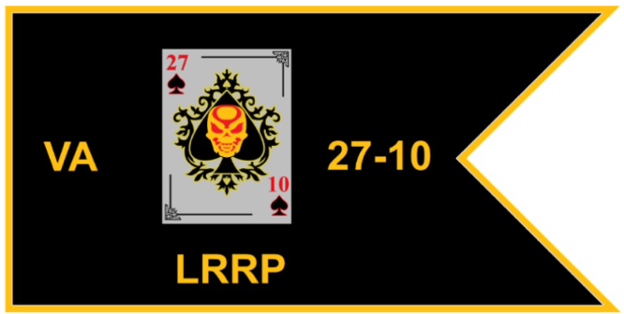

PURPOSE
The mission of the 27-10 Long Range Riding Platoon (LRRP) is to foster camaraderie within the
chapter through participants attendance at events outside the borders of our home state as well as in state
events that are approved by the 27-10 Chapter Board of Directors. In addition, it is to encourage all
participants to break through their personal riding barriers and put some hard-earned miles on their
motorcycles. The LRRP is strictly voluntary and is open to all chapter participants who successfully
complete the requirements for award of the chapter LRRP patch. As an added benefit the LRRP roster
will be used to maintain a record of a participant’s mileage that was devoted to non-profit events. This
mileage may be deductible from the participant’s income taxes at the end of the calendar year thus
providing an added incentive for participants to attend these events. Participation will also foster
support to all veterans. This is a program designed to bring forth camaraderie and understanding amongst
the members/participants of the chapter. It is not designed as a method to segregate members from one
another.

PATCH
The 27-10-chapter LRRP award shall be a patch in the shape of a military guidon. The color of
the patch shall be black with a gold border. The lettering will be gold for the “VA”, “27-10” and
“LRRP” on the patch. The 27-10 LUA is centered. The size of the patch will be approximately 4 ¼
wide x 2 ½ inches tall.

RECOGNITION
Each chapter participant who completes the 27-10 LRRP requirements shall be authorized to wear
the LRRP Guidon. These patches recognize chapter members/participants for their
long-distance riding accomplishments. Each awardee shall be entitled to continue wearing this award
regardless of their chapter affiliation should they leave 27-10.

OVERVIEW
The 27-10 Chapter LRRP one time participation fee may be made at any time and does not exclude
any miles logged before payment. All miles logged will become effective on day one, when an
individual begins riding with the chapter and will run continuously throughout duration of their
participation with the chapter. Upon completion of eligibility requirements participants will be awarded
the LRRP Guidon. All patches will be awarded at our chapter’s annual Christmas party recognizing total miles for current year as well as total cumulative miles accumulated from previous years while assigned to chapter 27-10. The 27-10 chapter LRRP is not mandatory, participation is optional to all chapter members.

QUALIFICATIONS
To be eligible for award of the Chapter LRRP patch you must meet the following criteria:
1. Those persons eligible to participate are (Full, Support, Auxiliary and Family members),
riders/passengers.

a. Family Member for LRRP purposes is defined as the son or daughter of a member.
Participation in LRRP does not extend to or include brothers, sisters, aunt’s uncles, cousin,
niece, nephew, girlfriend or boyfriend.

2. Since riding motorcycles is a key portion of the overall CVMA mission the only mode of
transportation allowed for the LRRP is the motorcycle. Hauling your motorcycle to events by
truck, trailer or any means other than riding it is not permitted and event miles will not count
towards LRRP. Traveling to an event by any means other than a motorcycle then obtaining a
bike at the event location is not permitted under LRRP, those event miles will not count.
Additionally, for miles to count you must be wearing your CVMA vest. The only exceptions
being that during periods of inclement weather it is acceptable to wear rain gear over or remove
the vest replacing it with rain gear. Removal of the vest will be acceptable in No fly zones and in
cases of extreme heat where safety may be of concern.

3. Travel to and from any chapter meetings, travel to/from events approved by the chapter Board of
Directors are usable miles for credit. Travel to/from State meetings or events, travel to/from out
of state approved CVMA events and rides are qualifying miles. Examples are; Blue Ridge
Thunder, Memorial Day/Veterans Day Parades, D-Day Anniversary Ride, 27-1 Poker Run, NC
CVMA Benefit Runs, NC Vietnam Vets Welcome Home, TN CVMA Benefit Runs, CVMA
National Meeting, Military Funeral Escort. “” Personal weekly rides or daily travel does not
constitute recognition for the LRRP.””

4. Good Faith Effort: If a breakdown occurs that renders the motorcycle inoperable while traveling
to, from or during an event and it becomes necessary to trailer the bike to a maintenance facility
or to the rider’s residence those miles ridden on the bike up to the malfunction will be honored
for LRRP.

5. START/FINISH: Each year mileage accumulation starts on the December 1st. Miles accumulation for the year finishes the last day in November. End of the year miles will be added to their total miles accumulated from each previous year of participation. At the 27-10 annual chapter Christmas party the most miles
accumulated for that year may receive special recognition.

6. Upon closure of each yearly mileage log (last day in November) the
Lead Road Captain/mileage records keeper will provide the chapter Secretary with a copy to be
kept with all other chapter records.

7. Mileage is typically obtained from odometer of the motorcycle that was ridden or may be
obtained from the ride route planned using MapQuest or Google Maps. Mileage starts and ends
at your place of residence.

8. To help in recording the miles traveled and the event name/location to the chapter Lead
Road Captain/miles Log into the CVMA web page. https://www.cvma27-10.org/ goto LRRP.

- For chapter approved events a CVMA 27-10 sign in roster will be available for chapter participants to obtain credit for attendance at the event and therefore record mileage associated with the event.
- Veteran events in our chapter calendar count as well but if you’re not sure please check with the Lead Road Captain/mileage records keeper.

NOTE: Participants are encouraged to maintain their own personal ride and mileage log.

** REMINDER **
National CVMA Long Range Riding Platoon – Finish the Mission! Inter-State and Tri-State awards can be
found on the national CVMA website at www.combatvet.us/lrrp .

Questions or inquiries may be directed to the chapter Lead Road Captain/miles record keeper or the
chapter BOD.

