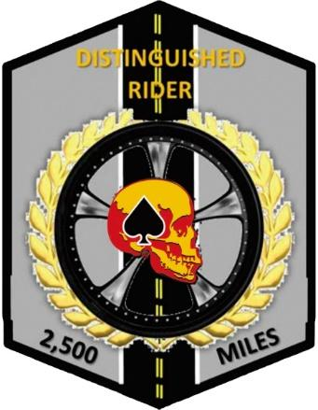

CVMA®
Virginia Chapter 27-10
DISTINGUISHED RIDER PROGRAM
(DRP)
COMBAT VETERANS MOTORCYCLE ASSOCIATION®
Virginia Chapter 27-10

Subject: CVMA Chapter 27-10 Distinguished Rider Program
Date: 22 February 2023
Duration: This program remains in force until modified by the Chapter Executive Board at the direction and under the authority of a majority vote by the chapter membership.

- General

- The Distinguished Rider Program (DRP) has been developed to serve three important functions. First, is to serve as an incentive program to encourage CVMA members to participate in their chapter rides and events. Second, the DRP serves an important role in rewarding and recognizing those CVMA riders and passengers who steadfastly participate in their chapter rides and events. Third, to ensure visibility of our organization to the public. Wearing of the CVMA logo is highly encouraged in the public sphere when supporting and veterans’ causes and camaraderie. Riding and camaraderie are founding principles of successful and enjoyable CVMA chapters. The DRP is a useful tool to help strengthen and grow our chapters.

- The Distinguished Rider patch is in the shape of an oblong hexagon and is 2.5 inches wide and 3.25 inches tall. It has a grey background and black border. The center of the patch contains a vertical two-lane road. Beneath the CVMA skull in the center of the patch is a motorcycle wheel and tire surrounded by a gold wreath. The words “DISTINGUISHED RIDER” are contained at the top of the patch. The patch is awarded for the completion of 2,500 miles ridden.
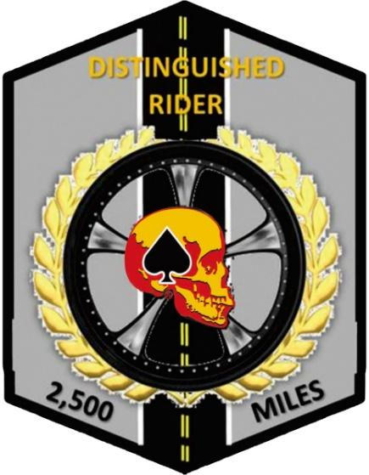
Distinguished Rider Program (Initial) Patch

- The Distinguished Rider chevrons have a grey background and black border. The center of the chevron contains a vertical two-lane road that is in line with the base patch. As subsequent chevrons are earned and affixed under the patch, the road appears loner to signify the lengthening journey. The first chevron is awarded at 5,000 miles the next at 10,000 miles and so on at 5,000-mile increments.

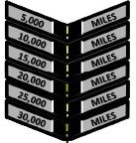
Distinguished Rider Program Chevrons

- DRP Guidelines

a. Eligibility - The patch may be awarded to:
    - Motorcycle Rider
    - Motorcycle Passenger
    - Driver of chapter support vehicle on long-distance rides where a support vehicle is deemed necessary by the chapter. If the support vehicle driver changes during that trip, only those miles driven by each driver can apply to that driver.
    - Member who is deemed medically unable to ride, but still attends the ride with the group in an alternate means of transportation.

- Allowable Mileage – The mileage is earned and accumulated from:
    - Riding to and from chapter business meetings.
    - Riding to and from any Sanctioned Event.
    - Riding to and from a State, Region, or a National meeting or rally.
    - A chapter sanctioned or sponsored motorcycle group ride (e.g., bike nights, weekend camaraderie / fellowship rides, and veteran events) at the chapter level or higher that have been announced through email, messenger apps, or social media.
    - Rides must be designated and approved by the 27-10 CO, XO, or DRP Coordinator BEFORE the ride is executed.

- Logging Mileage:
  - At the completion of the ride, it is the responsibility of every rider to enter their miles on the website https://www.cvma27-10.org LRRP section. The member submitting mileage must enter it on the site no later than seven (7) days after completion of the ride.
  - Any member transferring in from another chapter who wishes to have their mileage transferred must have the 27-10 DRP POC contact the transferees losing chapter DRP POC or officer to verify his/her miles.
  - The designated DRP POC will maintain a mileage log and update accumulated mileage totals, as necessary. At a minimum, a report will be generated in preparation for monthly business meetings.

- The designated DRP POC will coordinate ordering the DRP patch or chevron for award to the individual who has accumulated miles with chapter funds through CVMA Chapter 23-6. CVMA Chapter 23-6 is the sole owner of the DRP patch and chevron design.

- At the monthly business meeting, the DRP POC will announce those individuals that are within 200 miles of their patch or chevron.

- Event Type Definitions:

- National Sanctioned Event: Events that have been sanctioned by the National Board of Directors (NBOD) as providing credit toward yearly and Life membership (i.e., National Meeting, State Meeting, Wreaths Across America, etc.).

- Chapter Sponsored Event: Events that have been coordinated, managed, and/or co-sponsored by a CVMA Chapter, whereas participation in such an event serves to benefit individuals or organizations outside of the CVMA (i.e., fundraising).

- Chapter Sanctioned Event: Any event that does not meet the criteria above but meets the eligibility criteria for the accumulation of miles (i.e., morale and camaraderie rides, bike nights, non-sponsored Veteran events, etc..).

- This policy will be reviewed by a chapter-appointed or volunteer committee consisting of at least three FM’s periodically, or as deemed necessary by a majority vote of the Chapter.

Approved by:
CVMA® Chapter 27-10
22 February 2023

